**My operating system** is windows OS, edition windows 11 pro.

Installed it already, updated it by following these steps

opened settings, navigated to Windows Update in the left-hand menu, clicked check for updates menu and downloaded and installed available updates.

**For my programming languages and work flow** **I downloaded and Installed Visual Studio as my Integrated Development Environment.**

First step I searched Visual Studio Code on my browser.

I clicked on download for windows and it started downloading the vs code installer.

once the download was complete, I located the downloaded installer file, which was typically in downloads folder.

Double clicked on installer file and run as administrator

The installer prompted setup options. I chose the installation location added VS code to the Start Menu and desktop. Clicked on the "Next" button to proceed.

Selected additional tasks, such as associating file types with VS Code, and clicked "next"

clicked on the "Install" button and the installation process began

After the installation was complete. I Clicked on the "Finish" button to exit the installer.

I installed the following extensions for virtual studio code:

1. Prettier – code formatter
2. Code runner
3. Matplotlib
4. pylance

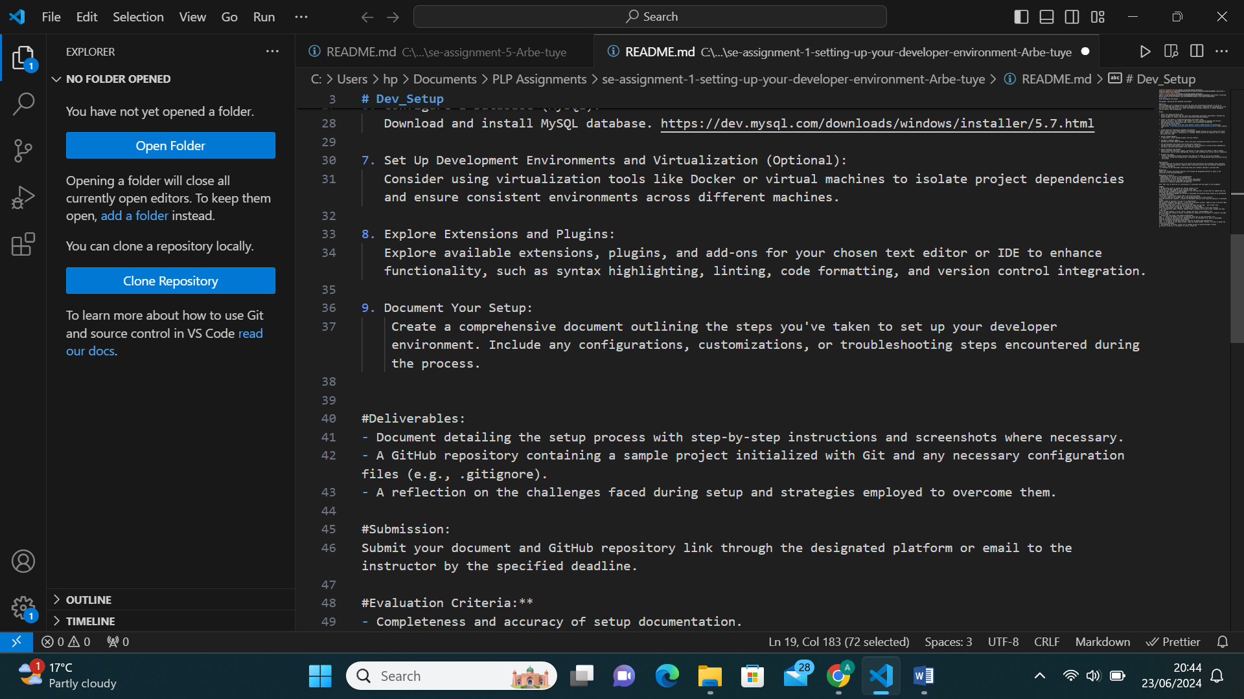

3. **Git configuration**: Opened a terminal command prompt on windows and run git config --global user.name "Arbe Tuye"

To set my email address I run git config --global user. email "arbietuye@gmail.com"

Went to GitHub and created an account. Initialized Git repository for my project "Assignment-Developer-Environment" and made my first commit.

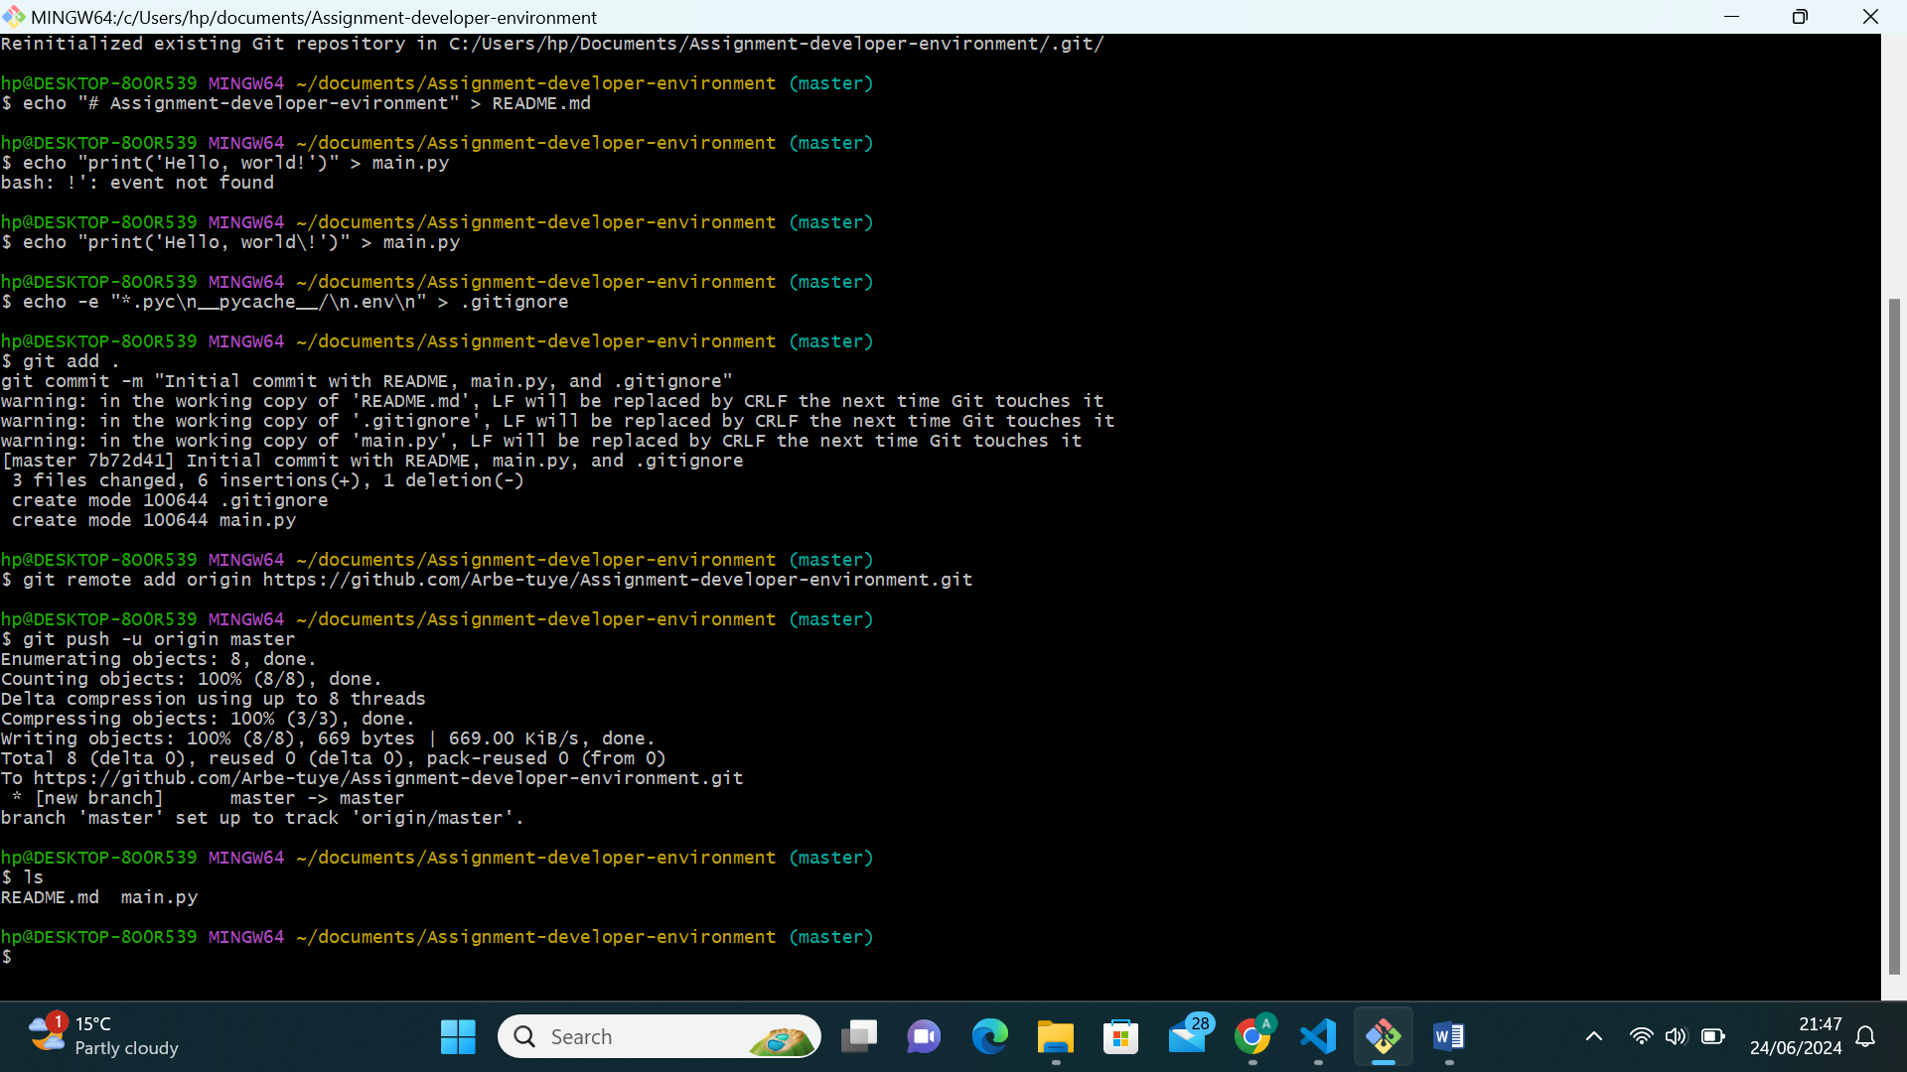

4. **python installation**

Visited the link <https://www.python.org/downloads/>

Step - 1: Selected the Python's version to download, which was in this case Python 3.12.3

step -2: Clicked on the Install now, Double-clicked on the executable file, which is downloaded; Selected Customized installation and proceeded

step - 3: Clicked on the Add Path check box, and set the Python path automatically.

step - 4: run python on the command prompt. Typed the command python -version, to verify if python was successfully downloaded.

5. pip enabled me to install virtual environment for Django project by passing message to python

To install virtual environment, I run python -m install virtual env

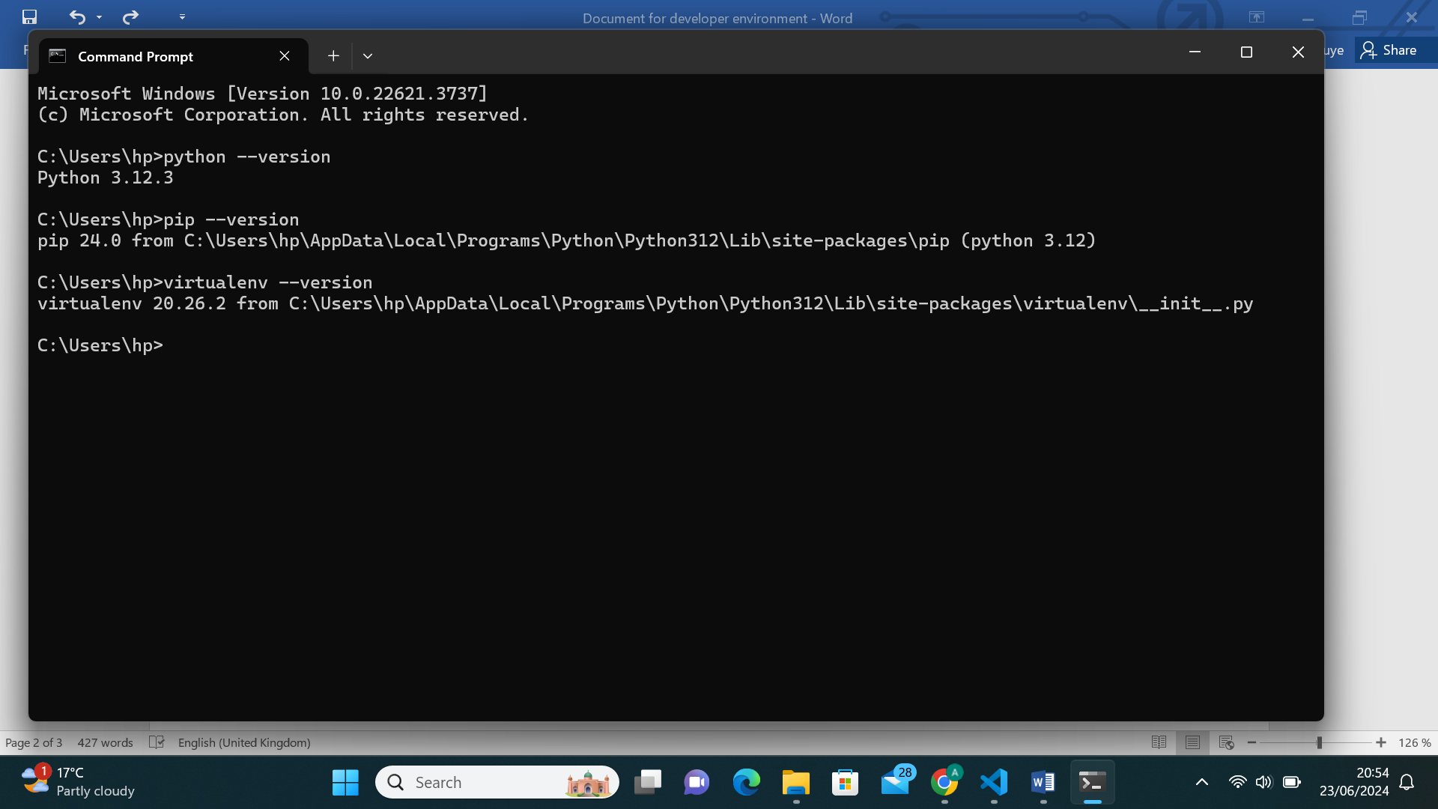

6. **MSQL installation**

Went to my browser and searched <https://dev.mysql.com/downloads/installer/>

Selected the full version (B) which contains all MySQL Windows products, including the MySQL Server.

Ignored the option of signing up for a MySQL Community and started my download.

Once the download is complete, I executed the MySQL Installer file from the download folder.

Accepted the Oracle license agreement terms, proceeded to choose server only, which is used to install an instance of the MySQL Server and forgo other MySQL products. Clicked execute.

Configured MySQL Server on Windows.

**Troubleshooting Steps**

* Resolved version conflicts by using virtual environments (e.g., virtualenv for Python)
* Verified environment variables.